Cardura XL (doxazosin) Extended Release Tablets, 4mg and 8mg Class II - Retail Level Recall - CUSTOMER CARE TALK TRACK

Background Information: NCQA made an update to their standard requesting communication be sent to members and prescribers affected by any recall classified as a Class II by the FDA except for wholesale level recalls. Communication is being sent to members and prescribers of NCQA delegated clients to inform them of the limited recall. The distributor is not requiring any action on the part of consumers for these recalls.

This recall affects:

Product: Cardura® XL (doxazosin) Extended-Release Tablets, 4mg
NDC: 58151-0078-93
Lot Number/Expiration Date: Lot: 8182298, Exp. 10/31/2025

Product: Cardura® XL (doxazosin) Extended-Release Tablets, 8mg
NDC: 58151-0079-93
Lot Number/Expiration Date: Lot: 8181625, Exp. 12/31/2025

Customer Care Talk Track:

** Please ensure to disposition all recall calls to code “1116” **

Q# | Question | Answer
1 | Why did I receive a recall notice? | Our records indicate that you may have recently received a prescription for a product affected by a limited recall from your retail pharmacy.  For more information, call the distributor listed on the letter or visit their website. You may also call the United States Food and Drug Administration (FDA) toll-free at 1-888-INFO-FDA (1-888-463-6332) or visit www.fda.gov.
2 | May I return the rest of the recalled product that I have? | The distributor is not requiring any action on the part of consumers for these recalls.
3 | Should I stop using the recalled product? | Please contact your prescriber with any questions or concerns about this recall or your use of the product.

Additional Information:

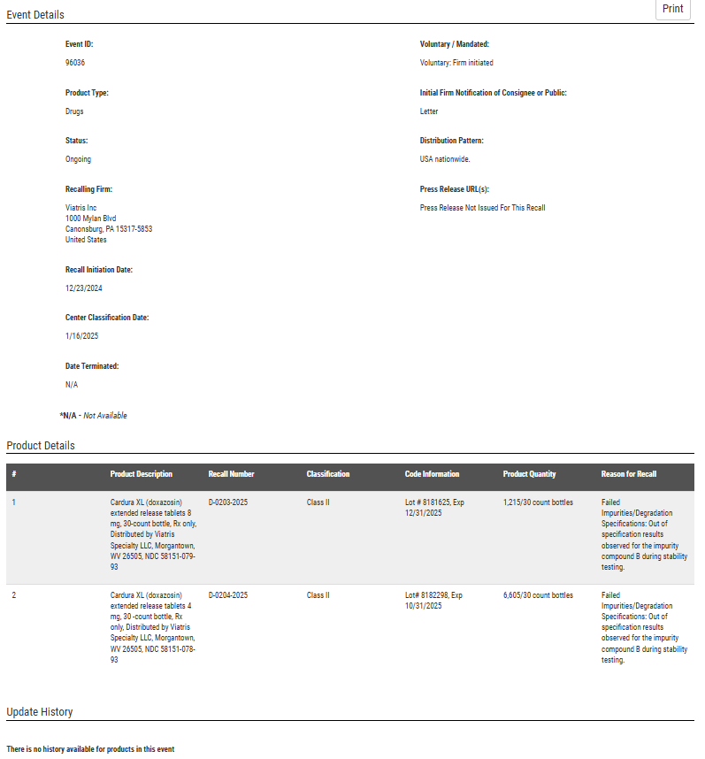

Top of the Document
Not To Be Reproduced Or Disclosed to Others Without Prior Written Approval
ELECTRONIC DATA = OFFICIAL VERSION / PAPER COPY = INFORMATIONAL ONLY

